KUIS 1
- The likely location of a mobile device in the home is as follows:
Adult bedroom: 0.03
Child bedroom: 0.15
Other bedroom: 0.14
Office or den: 0.40
Other rooms: 0.28
- What is the probability that a mobile device is in a bedroom?
- What is the probability that it is not in a bedroom?
- Suppose a household is selected at random from households with a mobile device, in what room would you expect to find a mobile device?

- Factory workers are constantly encouraged to practice zero tolerance when it comes to accidents in factories. Accidents can occur because the working environment or conditions themselves are unsafe. On the other hand, accidents can occur due to carelessness or so-called human error. In addition, the worker’s shift, 7:00 A.M.–3:00 P.M. (day shift), 3:00 P.M.–11:00 P.M. (evening shift), or 11:00 P.M.–7:00 A.M. (graveyard shift), may be a factor. During the last year, 300 accidents have occurred. The percentages of the accidents for the condition combinations are as follows:
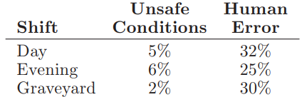

If an accident report is selected randomly from the 300 reports,
- what is the probability that the accident occurred on the graveyard shift?
- what is the probability that the accident occurred due to human error?
- what is the probability that the accident occurred due to unsafe conditions?
- what is the probability that the accident occurred on either the evening or the graveyard shift?

